Exercises:

First read related chapters from Szeliski’s Book. (<https://szeliski.org/Book/> )

1. Create a 2D Gaussian kernel using the formula in the slides (set $σ^{2}=2$, the center is in the middle of the kernel. Make your kernel size odd).
2. Convolve the kernel with the grass.png. Let the result be $C_{2}$. Show $C_{2}$.
3. We want to get the exact same result using 1D Gaussian kernels. What should the variance of the 1D filters be? Create necessary filters and apply them to grass.png. Let the result be $C_{1}$. Show $C_{1}$.
4. What is the Euclidean distance between $C_{1}$ and $C_{2}$?
5. See your kernels in 3 dimensions. E.g., the intensity of the pixels must be the z axis. This is called a surface plot. See an example in the matplotlib gallery.

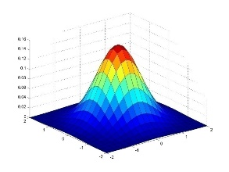

Notes:

* Use jupyter notebook. Use a different cell for each exercise.
* Do not use loops. (Do not use while or for loops).
  + E.g. for distance calculation, do not use loops or library functions.
  + While creating gaussian kernels, do not use loops or library functions.
* You can use library functions for convolution. E.g. cv2.
  + Python filtering:
    - im = cv2.filter2D(im,-1,ker)
  + Python convolution:
    - ker = cv2.flip(ker)
    - im = cv2.filter2D(im,-1,ker)
  + Or use scipy.signal.convolve2d

Submit to the link: <https://www.dropbox.com/request/3EkCgwhe0P6fAGZXV9Zw>

Deadline: Gelecek derste upload edilmiş olmalı.